Organising your code.

Version control
Author | Marcos Lara
When | 10-May-2024
Why | Provide a step-by-step guide to implement Grafana monitoring.
Version | 1.0
Note: | Edited on 5-Jun-2025: replaced image with code and added an example of an OpenAPI specification document.

When you create a minimal dotnet Web API, all your code is in the Program.cs
If you intend to add more functionalities or use other REST methods besides GET, it would be a good idea to refactor your code by creating new folders and moving part of the code from Program.cs to these new locations.

- Create your project
dotnet new webapi -n OrganiseWebApi

- Create your endpoint.
cd OrganiseWebApi
mkdir EndPoints
copy Program.cs EndPoints/WeatherforecastEndPoint.cs

- Create your services
mkdir Services
Copy Program.cs Services/WeatherforecastService.cs
- Modify your Program.cs
Remove the implementations from Program.cs for use in the Services and the Endpoints.
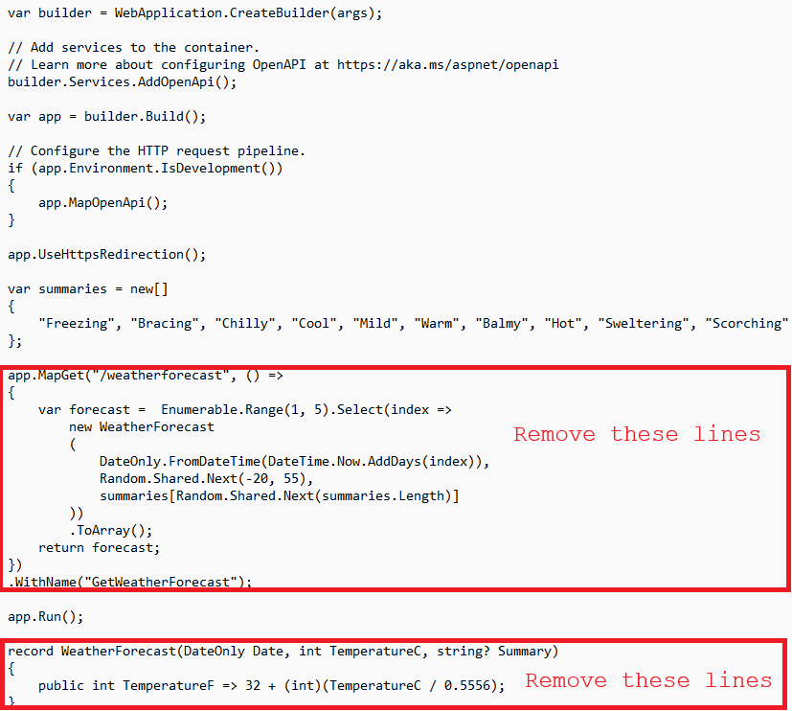

Then your Program.cs will be something like this:
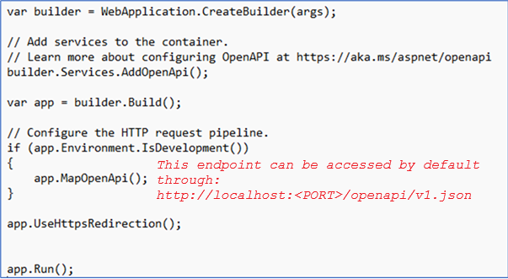

- Modify your endpoint class.
The idea is to create a class extension for WebApplication.
As a class extension, we need to define it as static.
The extension method needs to be declared as receiving a parameter preceded by the word ‘this’.
Your REST/API methods, (GET, POST, PUT, DELETE, ..), will all be declared here; however, their functionalities will be defined in services.
Starting to declare the namespace. The namespace is a path where your class is declared. This will be used for other codes to find where your code is, for example:

D:\dotnet_tips\OrganiseWebApi\EndPoints>

In the example above, the folder OrganiseWebApi is where your project was created.
The folder EndPoints is where you will create your class EndPoint. in this case, the namespace that you will need to create is:
OrganiseWebApi\EndPoints in C# dotnet will be OrganiseWebApi.EndPoints, then create your
namespace OrganiseWebApi.EndPoints;

Your WeatherforecastEndPoint.cs needs to be something like this:

// This is necessary as we need to call the method GetWeather() that is inside a class
// declared in the code inside this folder:
// OrganiseWebApi\Services\WeatherforecastService.cs
using OrganiseWebApi.Services;

using OrganiseWebApi.Services;

namespace OrganiseWebApi.EndPoints;

public static class WeatherforecastEndPoint
{
public static WebApplication MapWeatherEndPoints(this WebApplication app)
{
// The WeatherService is injected here
app.MapGet("/weatherforecast", (WeatherService wather) =>
{
return wather.GetWeather();
})
.WithName("GetWeatherForecast");

return app;
}
}

- Modify your service class.
namespace OrganiseWebApi.Services;

public class WeatherService
{
public static readonly string[] summaries = new[]
{
"Freezing", "Bracing", "Chilly", "Cool", "Mild", "Warm", "Balmy", "Hot", "Sweltering", "Scorching"
};

public IEnumerable<WeatherForecast> GetWeather()
{
return Enumerable.Range(1, 5).Select(index => new WeatherForecast
(
DateOnly.FromDateTime(DateTime.Now.AddDays(index)),
Random.Shared.Next(-20, 55),
summaries[Random.Shared.Next(summaries.Length)]
))
.ToArray();
}

public record WeatherForecast(DateOnly Date, int TemperatureC, string? Summary)
{
public int TemperatureF => 32 + (int)(TemperatureC / 0.5556);
}
}

- Modify the Program.cs file.
Add the call to the new extension method created.
using OrganiseWebApi.Services;
using OrganiseWebApi.EndPoints;

var builder = WebApplication.CreateBuilder(args);

builder.Services.AddOpenApi();

//This allows the WeatherService to be injected
//into any class/method that needs it.
builder.Services.AddScoped<WeatherService>();
// As Scoped this class will be instantiated
// for every request and will last
// till the processing the whole request

var app = builder.Build();

if (app.Environment.IsDevelopment())
{
app.MapOpenApi(); //This will allows us to see the OpenApi specification document
// using this link: http://localhost:5003/openapi/v1.json
}

app.UseHttpsRedirection();

//This will run the Extension
//class/method.
app.MapWeatherEndPoints();

app.Run();

- Test your web API:
Use this URL in the web browser:
localhost:5003/weatherforecast
Please note that the port may vary.

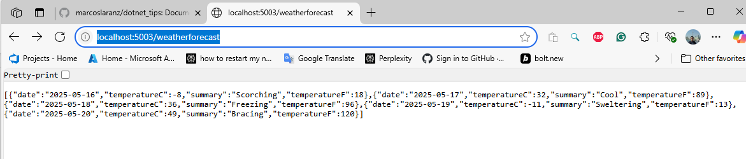

See the OpenAPI specification document for your API:

localhost:5003/openapi/v1.json
{
"openapi": "3.0.1",
"info": {
"title": "OrganiseWebApi | v1",
"version": "1.0.0"
},
"servers": [
{
"url": "http://localhost:5003/"
}
],
"paths": {
"/weatherforecast": {
"get": {
"tags": [
"OrganiseWebApi"
],
"operationId": "GetWeatherForecast",
"responses": {
"200": {
"description": "OK",
"content": {
"application/json": {
"schema": {
"type": "array",
"items": {
"$ref": "#/components/schemas/WeatherForecast"
}
}
}
}
}
}
}
}
},
"components": {
"schemas": {
"WeatherForecast": {
"required": [
"date",
"temperatureC",
"summary"
],
"type": "object",
"properties": {
"date": {
"type": "string",
"format": "date"
},
"temperatureC": {
"type": "integer",
"format": "int32"
},
"summary": {
"type": "string",
"nullable": true
},
"temperatureF": {
"type": "integer",
"format": "int32"
}
}
}
}
},
"tags": [
{
"name": "OrganiseWebApi"
}
]
}

